Lesson 13 –PASSIVE – DIFFERENT TENSES, Friday 17th April

- Yesterday you learnt PRESENT SIMPLE PASSIVE. Za vajo je bilo treba narediti kar nekaj primerov PASSIVE v sedanjiku. Preveri rešitve, kako ti je šlo.

SB p.57/exercise 5

- A lot of CO2 is released by cars.
- The forests are burnt down by farmers.
- Most of the world’s rain is made by forests.
- Forest fires are photographed by satellites.
- Millions of animals are killed by deforestation.
- Three per cent of greenhouse gases are produced by aeroplanes.
- The sun’s heat is trapped by greenhouse gases.
- Extreme weather is produced by climate change.
- Carbon dioxide is absorbed by trees.
- Electricity is produced by power stations.

WB p.44 exercise 3
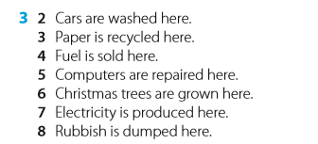

WB p.45 exercise 6
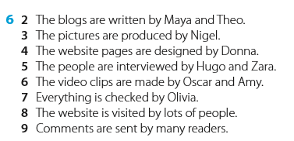

- PASSIVE in DIFFERENT TENSES. Today you are going to learn how to make passive in 3 more tenses (Past Simple, Future Simple and Present Perfect Simple) Watch the video and then copy the Power Point with examples in your notebook.

VIDEO – watch and learn (poglej in poslušaj)
POWERPOINT – copy in your notebook (prepiši v zvezek)

- Open your STUDENT BOOK on page 58 and read the story of Smart Alec’s plan.

- Now it’s time to do some exercises on page 59 exercise 4. Rewrite the sentences in the passive in your notebook. Keep the same tense. Follow the steps.

- You do know that if we were in school you would get a worksheet full of passive sentences on both side to practice, don’t you?

And at home you only have to do 2 pages in your workbook. So OPEN YOUR WORKBOOK and do exercises on pages 46 and 47.

Don’t forget to check the lesson plan in XOOLTIME and take a picture of the passive in your notebook for me to see. Ne pozabi potrditi prejem gradiva na XOOLTIME in naložiti sliko zvezka, kjer imaš prepisano vse o PASSIVU.

