Week 4: Lesson 9 - REVISION – ENVIRONMENTAL PROBLEMS (Monday, April 6th)

1. Do the two quizzes below and use your REAL name:

quizizz.com/join?gc=663312

quizizz.com/join?gc=229761

2. Watch the videos below:
https://www.youtube.com/watch?v=eRLJscAlk1M&frags=pl%2Cwn

https://www.youtube.com/watch?v=XAi3VTSdTxU&frags=pl%2Cwn

https://www.youtube.com/watch?v=BPJJM_hCFj0

Now send an email to your teacher and write what you think about the videos and what message they convey.

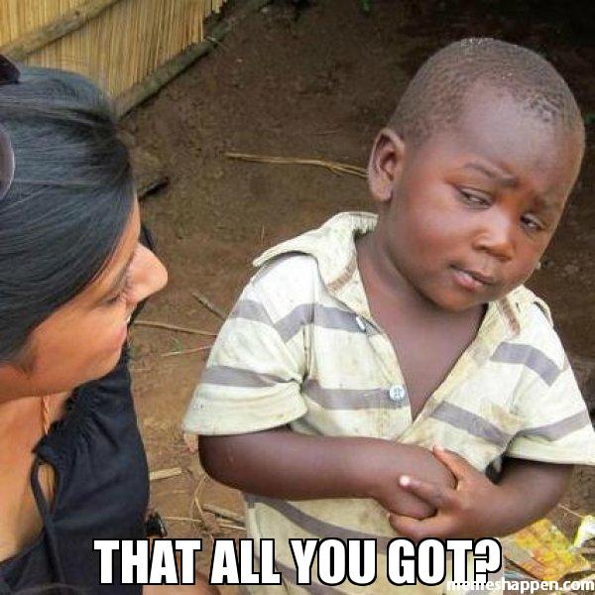
That’s it!

