NAVODILA ZA DELO – 8. URA – petek, 3. 4.
- 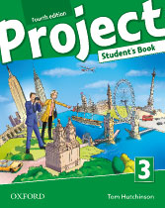Open your book on page 54.
Look at exercise 1. JUST THINK – what would your answers be?
Then watch the video and check your ideas.
https://screenrec.com/share/cOCXmk2hM7
YOU DON'T HAVE TO COPY INTO YOUR NOTEBOOK.

- Open your notebook. Write a title: REVISION 4.
Do exercises 2, 3 and 4 on page 54 in your book. Write the sentences into your notebook.
Primere V CELOTI NAPIŠI V ZVEZEK.

- Open your WORKBOOK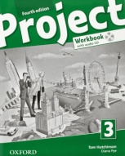 on pages 42 and 43.
Do the Progress Check – exercises 1-5 and I can...

PREVERI SVOJE ZNANJE. REŠI NALOGE KOT KRATKO PREVERJANJE. REŠITVE TI BOM POSREDOVALA NAKNADNO eAsistentovega PREKO KANALA oz. bodo objavljene na SPLETNI STRANI.

