NAVODILA ZA DELO – 17. URA (Friday, 8th May)
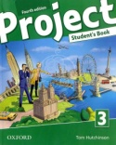Open your book on page 60.
Read and listen to the text again.
Click here
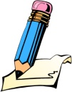Write the title MAKING PEOPLE AWARE. Go back to the text and find English expressions. Copy the words and translations.
odpadki
pločevinke
jeklenke (za kisik)
razkrajati se
oprema
divje odlagališče odpadkov
razstava
globa (denarna kazen)

Now look at page 61 and do exercise 3a into your notebook.
Look and listen to exercise 4a,b. .
YOUR WORK FOR TODAY IS FINISHED. GO TO XOOLTIME AND ANSWER SOME QUESTIONS.

