NAVODILA ZA DELO – 18. URA Monday, 11th May
WELCOME TO THE 8TH WEEK OF HOMESCHOOLING. How are you? I hope you are fine and well-rested after the weekend. Ready for a new challenge?
First check your work from last time:
Odpadki – rubbish (tudi waste, garbage, trash, recycling)
Pločevinke - cans
jeklenke (za kisik) – oxygen bottles
razkrajati se – to decompose
oprema – equipment (npr. tents, sleeping bags , oxygen bottles...)
divje odlagališče odpadkov – a rubbish dump
razstava – a display (tudi exhibition)
globa (denarna kazen) – a fine
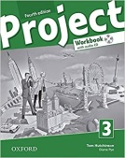Today, you will open your workbook on pages 48 and 49 and do exercises 1-7.
Exercise 1 is a listening exercise, if you have a CD you can listen, if you can't find it, read the tapescript and then do the exercise.
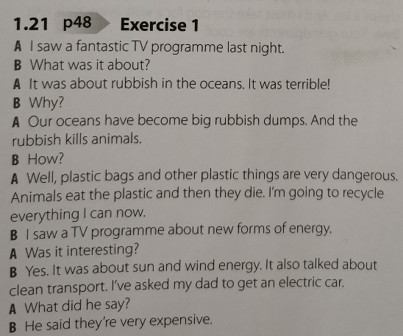
WHEN YOU FINISH, TAKE A PHOTO OF YOUR WORK AND UPLOAD IT IN XOOLTIME.

