NAVODILA ZA DELO – 10. URA (Friday, 10th April)
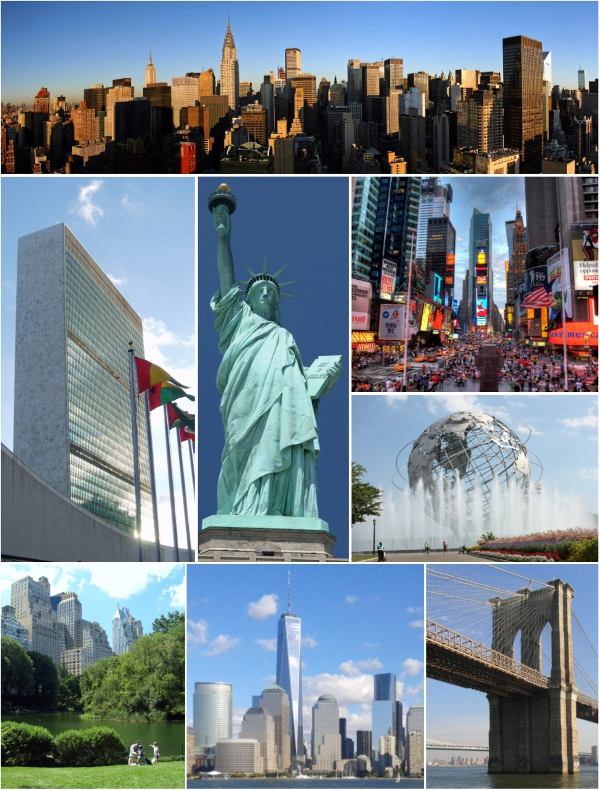
Take 10 minutes and revise the IRREGULAR VERBS.
Open your book on page 52. 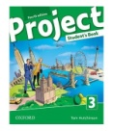
Look at the pictures. What do they show?
Read the text about New York. Do exercise 2 – find the things in the text. You don't have to write.
Now you can listen to the text.
https://elt.oup.com/student/project/level3/unit04/audio?cc=si&selLanguage=en
Click on
Write the title: NEW YORK, THE BIG APPLE into your notebook and answer the questions in exercise 3a. Write whole sentences.
Now watch the video about »the city that never sleeps«, »the city of dreams«.
https://www.youtube.com/watch?v=MtCMtC50gwY
(če želiš lahko klikneš na nastavitve in vklopiš podnapise)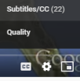
Try to find the answers to the following questions.
- Where is New York situated?
- How many people live in New York?
- Many i_______________________ moved to New York. (=people who leave their country and move to another).
- What are New York’s iconic symbols (name at least 3)?
- What is the Rockefeller Centre?
- It’s also called “the city of a spree”. What does this mean?
- What is one of the most visited tourist attractions in the world? (It’s in New York).
- What’s the best chill-out space in New York?
- What happened on 11th September 2001?
- What’s the name of the famous bridge that connects Manhattan with Brooklyn?
You can watch again and pause the video when you find the answer to each question.
Write it down in your notebook.

YOUR LESSON FOR TODAY IS FINISHED. CHECK HOW MUCH YOU'VE LEARNT BY DOING A QUIZ.
USE YOUR REAL NAME!
quizizz.com/join?gc=907867
PIN: 907867

