NAVODILA ZA DELO – 12. URA (Present Perfect positive and negative) (Friday, 17th April)
Last time we started with the Present Perfect Simple. Today you are going to practice POSITIVE and NEGATIVE FORM.
REVISE: Read the rules in your notebook or watch the video again.
https://screenrec.com/share/AcMsBfye1L

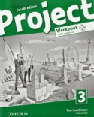Open your WORKBOOK on pages 44 and 45. Do exercises 1,2,3,4,5,6.
If you have a CD you can listen and check your answers in exercise 5.
Later I will send you the answer key, so you will be able to check your work. If there are any problems write and ask in the e Asistent channel.

LIVE WORKSHEET:
https://www.liveworksheets.com/fk142735pc
Follow the link and do the exercises. When you finish, you can click and 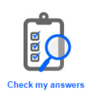.

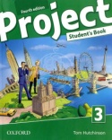To finish the lesson, open your book on page 57. Look at exercise 7 a and listen. WHAT HAVE THE PEOPLE DONE? Ustno tvori povedi za vsak par sličic, kot kaže primer v nalogi b.
Click here.

NE POZABI!
TVOJE DELO ZA DANES JE KONČANO.
POJDI V SPLETNO UČILNICO XOOLTIME, POTRDI OGLED SNOVI IN REŠI KRATKO NALOGO O GLAGOLSKEM ČASU PRESENT PERFECT SIMPLE TENSE.

