NAVODILA ZA DELO – 13. URA (Present Perfect Questions) (Tuesday, 21st April)
Last time we practiced POSITIVE and NEGATIVE FORM, today you will learn how to form QUESTIONS.

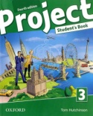 Open your book on page 58. Read and listen to the comic in exercise 1.
Click here.. Look at exercise 2, how would you fill in the sentences?

Go back to the text and FIND examples of QUESTIONS in PRESENT PERFECT SIMPLE. (V besedilu poišči čim več primerov vprašanj v polpretekliku.)

First watch the video: https://screenrec.com/share/NmJCl3h9w4 with the explanation.
Take your notebook and write PRESENT PERFECT SIMPLE QUESTIONS. Zapiši razlago iz priložene ppt predstavitve.

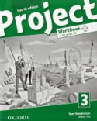Open your WORKBOOK on page 46 and do exercises 1, 2 and 3.
You will check the answers next time.

NOW YOUR WORK FOR TODAY IS FINISHED. JUST GO TO XOOLTIME, CLICK YOU'VE RECEIVED THE LESSON PLAN AND DO A SHORT EXERCISE OF FORMING QUESTIONS IN THE PRESENT PERFECT TENSE.

