NAVODILA ZA DELO – 14. URA (Present Perfect - utrjevanje) Friday, April 24th
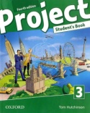 Open your book on page 59. Look at exercise 6a. Write abour your EXPERIENCE. What have or haven't you done so far?
V zvezek napiši naslov MY EXPERIENCE (Moje izkušnje). Na podlagi slik zapiši resnične povedi o sebi.

Last time we learnt how to form QUESTIONS.
Watch the video again: https://screenrec.com/share/NmJCl3h9w4
Be careful – HOW DO WE FORM QUESTIONS WITH WHO?
Sally and Jack have travelled to Italy. Who HAS travelled to Italy?
Who vedno sledi ednina, nikoli Who have...
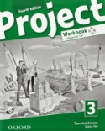Open your WORKBOOK on page 47 and do exercises 4, 5 and 6.
You will check the answers next time.

NOW YOUR WORK FOR TODAY IS FINISHED. JUST GO TO XOOLTIME, CLICK YOU'VE RECEIVED THE LESSON PLAN AND POST THE PHOTO OF YOUR NOTEBOOK – My experience

Tako je tvoje delo končano. Pred zasluženimi prvomajskimo počitnicami pa je tvoja naloga še, da preveriš svoje znanje tako, da rešiš VAJE ZA PREVERJANJE ZNANJA V SPLETNI UČILNICI XOOLTIME.
Popravke boš lahko videl ob koncu počitnic.

