NAVODILA ZA DELO – 19. URA Tuesday, 12th May
FIRST WATCH THE VIDEO TO REVISE PRESENT PERFECT SIMPLE.
Za ponovitev novega časa Present Perfect Simple, si lahko ogledaš celoten posnetek, posebej pa bodi pozoren na drugi del (od 1min40s): https://www.youtube.com/watch?v=hG-9OV36O04
WRITE INTO YOUR NOTEBOOK. BE CAREFUL WHERE IN THE SENTENCE YOU PUT AND ADVERB.
USTVARI ZAPIS V ZVEZKU. BODI POZOREN NA BESEDNI RED V STAVKU.
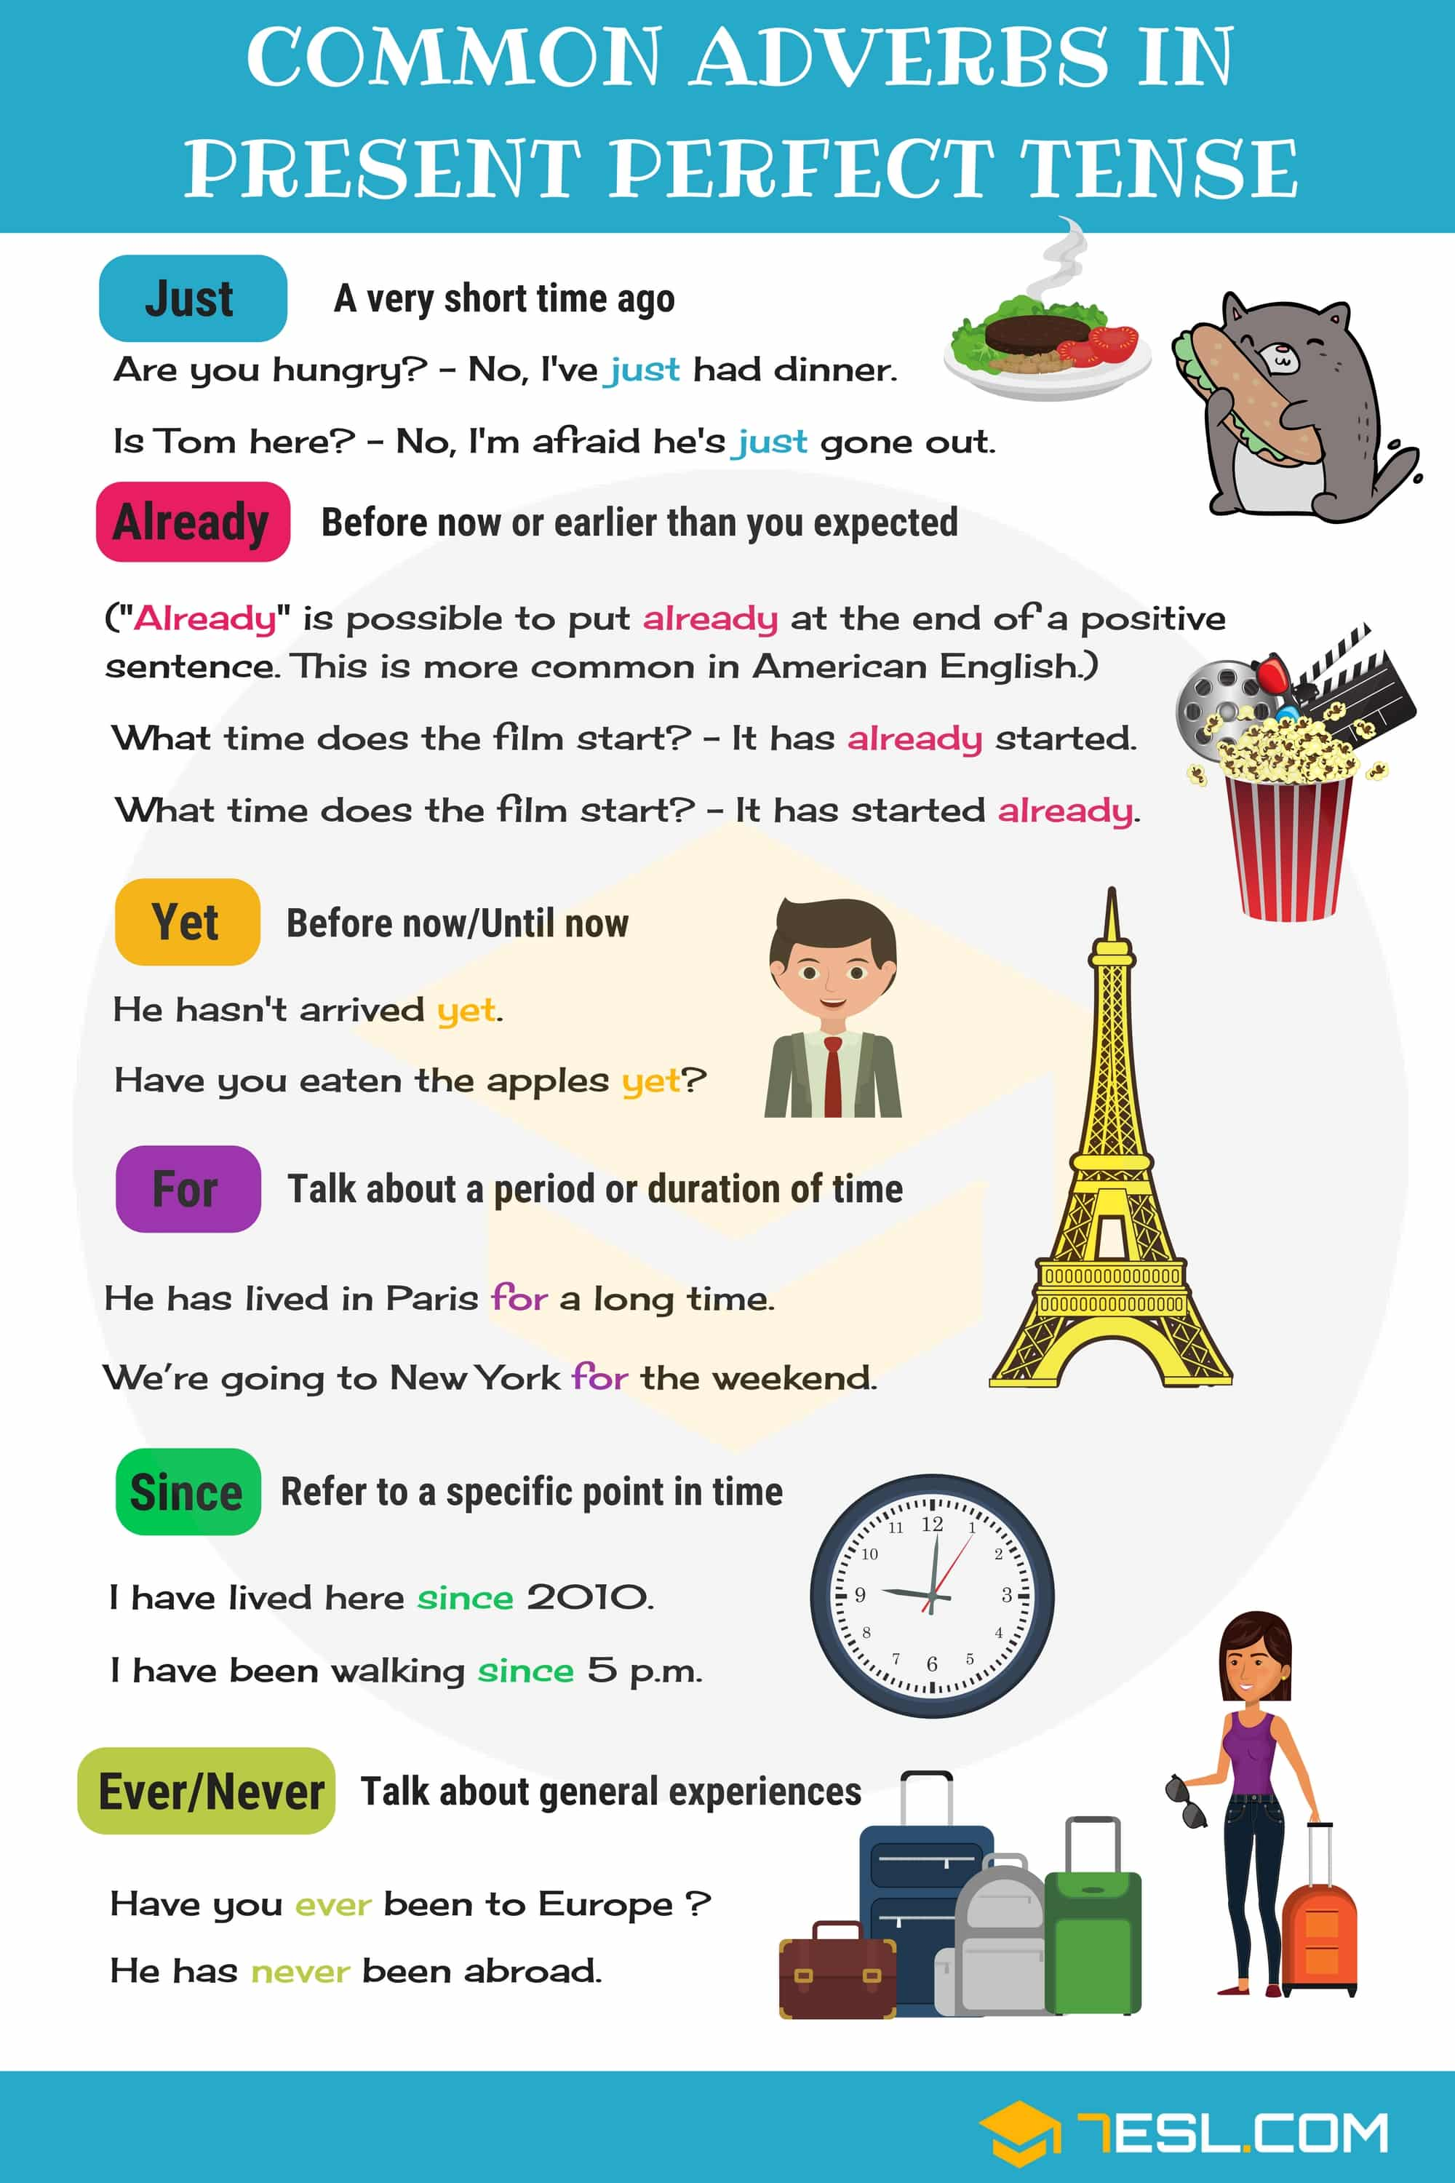
PRACTISE. READ AND DO THE EXERCISE: PRESENT PERFECT ADVERBS : https://www.liveworksheets.com/worksheets/en/English_as_a_Second_Language_(ESL)/Present_perfect/Present_perfect_adverbs_ka102798gr
Ko končaš, klikni na 'finish' in izberi 'email my answers to my teacher', za mail vpiši teacher.rules@gmail.com

