NAVODILA ZA DELO – 21. URA 8ac Monday, May 18th 2020
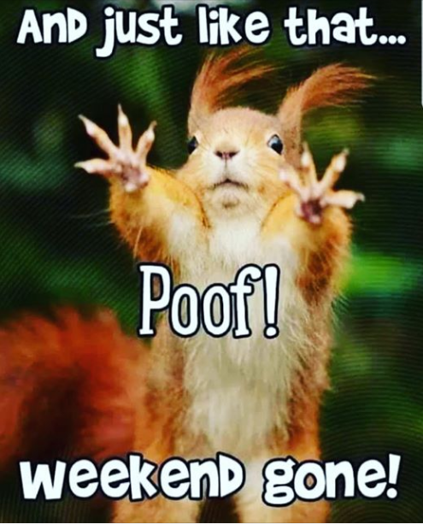
Today you will practise the difference between PAST SIMPLE (navadni preteklik) and PRESENT PERFECT SIMPLE (polpreteklik).
Ponovimo razlago s spodnjim posnetkom. OBVEZNO SI GA OGLEJ PRED REŠEVANJEM VAJ.
https://www.youtube.com/watch?v=p-jGuoeYU9E
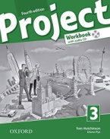Now open the workbook on pages 68, 69 and do PRESENT PERFECT AND PAST SIMPLE exercises 1 and 2.
Bodi pozoren na značilne prislove – SIGNAL WORDS
TO SHOW YOU UNDERSTAND THE RULES FOR THE TWO TENSES, DO AN ONLINE EXERCISE.
https://www.liveworksheets.com/qz542314fh
Ko končaš z delom, klikni
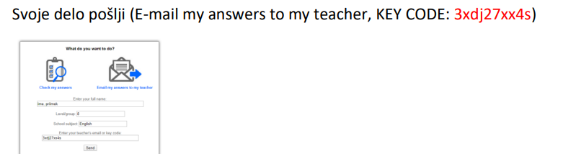
DANES NE ODDAJAJ ZAPISKOV, DA POTRDIŠ SODELOVANJE, REŠI KRATKO VAJO PAST SIMPLE AND PRESENT PERFECT V XOOLTIME.

