NAVODILA ZA DELO – 26. URA
CHECK YOUR WORK FROM LAST TIME. HERE ARE THE ANSWERS:
B p. 61/ 5 b Lewis Gordon Pugh:
1.In the Southern Ocean, near Antarctica
2. He swam 1 kilometre.
3. The water was zero degrees Celsius.
4. There were leopard sels.
5. The Arctic Ocean.
Yes, he's going back to the Arctic Ocean next year.
B p. 66/ Revision 5
2 b Megan has won a race, driven a go-kart, written song and seen a show. She hasn't done other things.
4 POSSIBLE ANSWERS: 2. Syd's just fallen off his bike. 3. Syd's just had a drink. 4. Syd's just cooked himself a meal. 45 Syd's just won a game of tennis. 6. Syd's just bought a DVD. Namesto 's, lahko uporabiš has.

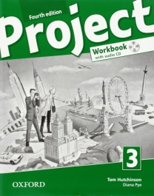 Today you will open your WORKBOOK and do PROGRESS CHECK 5 on pages 52,53.

EXTRA:
If you think you need some more practice, you can do exercises in your workbook on page 51 : 4,5,6.

YOU WILL CHECK THE ANSWERS NEXT TIME.

