NAVODILA ZA DELO – 27. URA
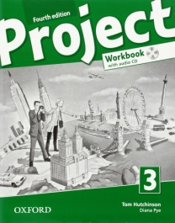First check your ANSWERS in the workbook (Progress Check on pages 52, 53).
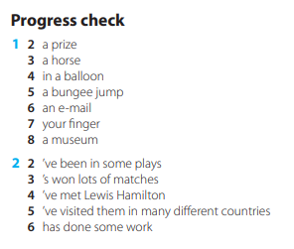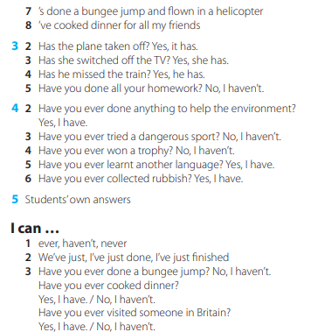
Today we are starting UNIT 6 – WHAT'S UP. People sometimes have different PROBLEMS – something is the matter/ something is wrong.
Look at the flashcards, click PLAY and make sure the speakers are turned on. Oglej si kartice, pritisni PLAY in poslušaj izgovorjavo.
https://quizlet.com/509701230/flashcards
Write the words into your notebook. Zapiši naslov WHAT'S THE MATTER in zapiši besede s kartic v zvezek (če kakšnega izraza kljub sliki ne razumeš, PREVERI POMEN.)

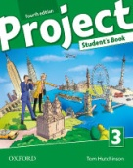Open your book on page 68. Look at exercise 1c – What is wrong with people in the pictures? Oglej si slike. Znaš povedati, kakšne probleme imajo ljudje na slikah?
Open your workbook on page 54 and do exercises 1 and 2.
EXTRA: V učbeniku si oglej nalogo 3a, nato pa poslušaj in preveri svoje zamisli – naloga 3b. Za poslušanje klikni na gumb.

